Exercise 8: Time-Series Architecture
Step 1: Architecting the Time-Series Collection in Cloud
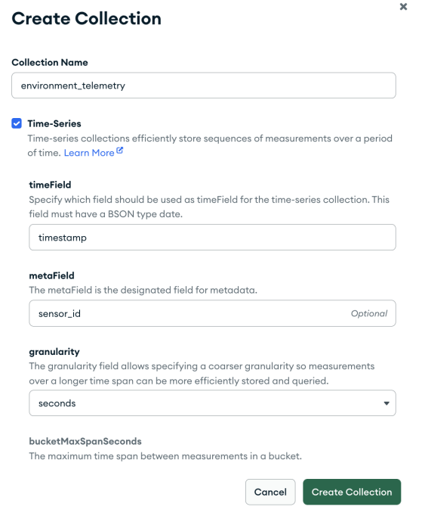

Step 2: Node-RED Middleware Transformation
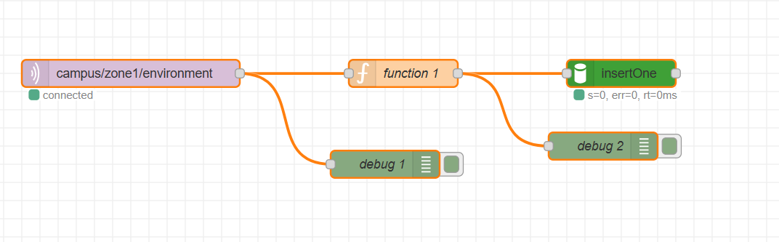
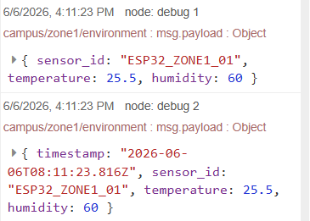

Step 3: Verifying Cloud Indexes and Bucket Storage
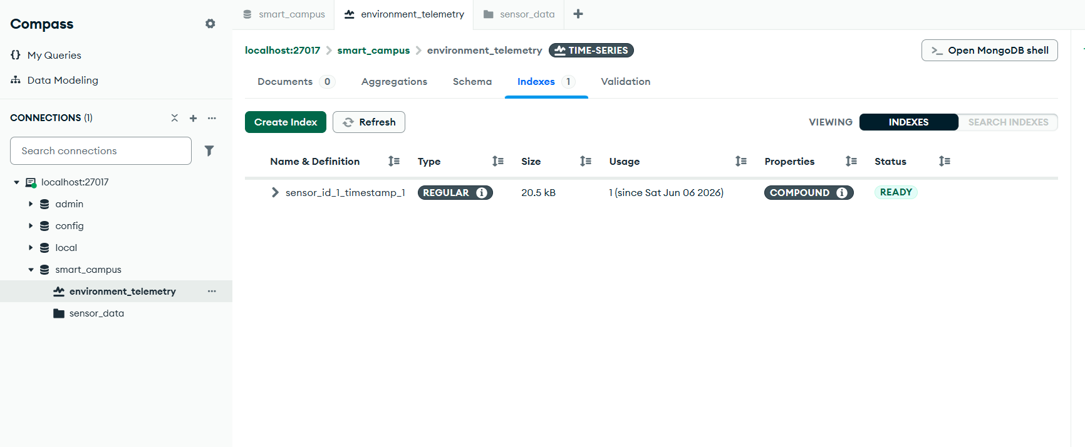

Part 4: Discussion & Architectural Analysis

Question 1: The Definition of Metadata

Why must metadata be a static identifier rather than a dynamic reading?
Under the hood, MongoDB uses the Bucket Pattern to handle massive data scales. It optimizes space by creating a single, highly compressed physical block ("bucket") for a unique metadata signature over a set window of time. Dynamic sensor telemetry (like a fluctuating temperature value) cannot be used as metadata because it changes continuously, whereas static labels (like sensor_id or MAC addresses) remain uniform across thousands of sequential packets.

What would happen if you accidentally set the metaField to a variable that changes every second?
If the metaField changes every single second, MongoDB's compression mechanism breaks completely. The engine will be forced to generate a brand-new physical bucket document for every single incoming message instead of grouping them together. This drastically expands database storage volume, balloons the index sizes, invalidates the time-series mathematical optimizations, and ultimately causes performance degradation or database crashes under high throughput.

Question 2: Middleware vs. Edge Timestamping
Why is server-side (middleware) timestamping safer and more accurate than relying on a $5 microcontroller?
- Lack of Hardware Real-Time Clocks (RTC): Budget microcontrollers like the ESP32 lack a built-in, battery-backed physical RTC hardware module. When powered on, they do not inherently know the true calendar time unless they perform network queries.
- Clock Drift and Synchronization Issues: If the microcontroller relies on internal software counters or loses its internet connection to Network Time Protocol (NTP) servers, its time synchronization drifts quickly, resulting in incorrect, chronological time markers.
- Power Interruption Reset: If a remote microcontroller suffers a brownout, power blink, or total battery loss, its internal timer resets back to zero epoch time upon reboot. If it continues publishing data before reconnecting to a time server, it will write corrupt historical timestamps into your database.
Using a central, highly reliable runtime environment like Node-RED running on an OS with atomic clock synchronization ensures that every arriving document is stamped with highly reliable, universally standardized, and consistent system time.

